Name of the Student: G. Manasa | Academic Year: 2024-25
Student Registration Number: 241U1R3007 | Year & Term: II&I
Study Level: UG | Class & Section: CSE-DS-2A
Name of the Course: Digital Electronics | Name of the Instructor: Nuzhath Farhana mam
Name of the Assessment: Lab-Report-8 | Date of Submission: 31-08-2025

Lab-Report 8

Simulation of Flip-Flops Using NAND and NOR Gates

Simulation of SR Flip-Flop Using NAND and NOR Gates

1.Objectives
- To design and simulate an SR flip-flop using NAND and NOR gates in SimulIDE.
- To verify the set, reset, hold, and invalid conditions.
- To understand the truth table and working of SR flip-flops.
- To analyse the difference between active-high (NOR) and active-low (NAND) SR flip-flops.

2.Software Required:
PC with SimulIDE software installed

3.Procedure

A) SR Flip-Flop using NOR Gates:
- Place 2 NOR gates, 2 switches for inputs (S and R), 2 LEDs for outputs (Q, \bar{Q}), VCC, and GND.
- Connect the output of NOR1 to input of NOR2, and output of NOR2 to input of NOR1 (cross-coupling).
- Apply the input combinations and observe the outputs using LEDs.

B) SR Flip-Flop using NAND Gates:
- Place 2 NAND gates, 2 switches for inputs (\bar{S}, \bar{R}), 2 LEDs for outputs (Q, \bar{Q}), VCC, and GND.
- Cross-couple outputs as in NOR version.
- Apply active-low inputs and verify the results.

4.Circuit Diagrams:

a.SR Flip-Flop Using NAND Gates

In a SR flip flop using NAND gates, two NAND gates are connected in a feedback loop. The inputs are S (Set) and R (Reset), and the outputs are Q and Q'.

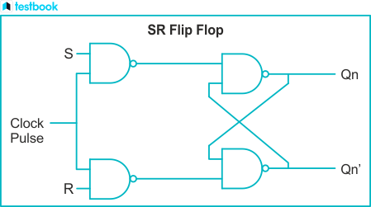

Truth Table for NAND-based SR Flip-Flop:
S | R | Q | Q'
0 | 0 | Previous State | Previous State (inverted)
0 | 1 | 1 | 0
1 | 0 | 0 | 1
1 | 1 | Invalid State | Invalid State

Simulation:

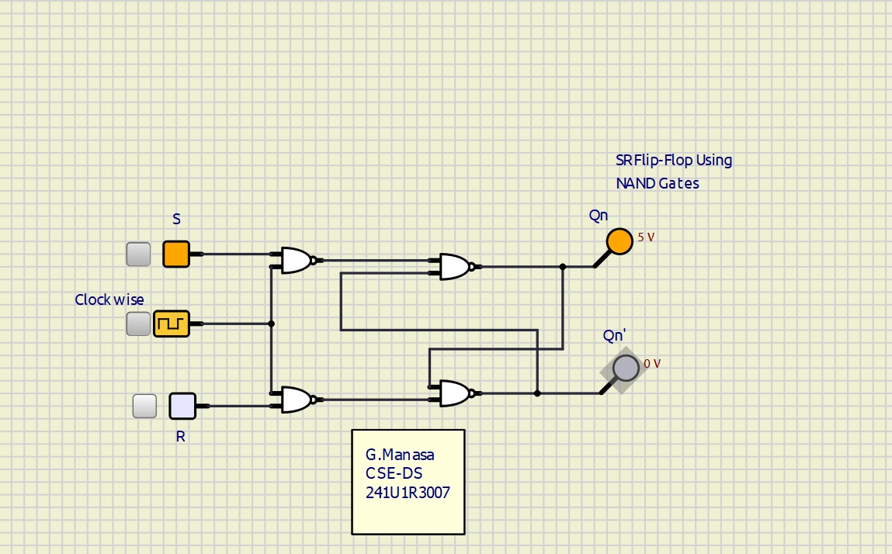
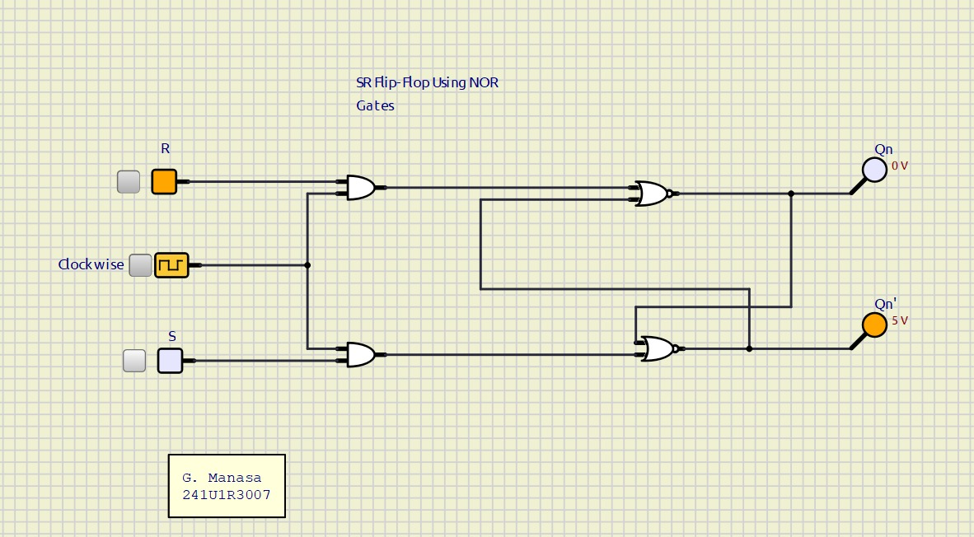

b. SR Flip-Flop Using NOR Gates
In a SR flip-flop using NOR gates, two NOR gates are connected in a feedback loop. The inputs are S (Set) and R (Reset), and the outputs are Q and Q'.
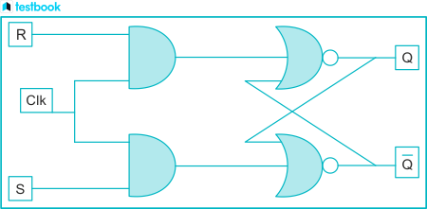
Truth Table for NOR-based SR Flip-Flop:
S | R | Q | Q'
0 | 0 | Previous State | Previous State (inverted)
0 | 1 | 0 | 1
1 | 0 | 1 | 0
1 | 1 | Invalid State | Invalid State
Simulation:


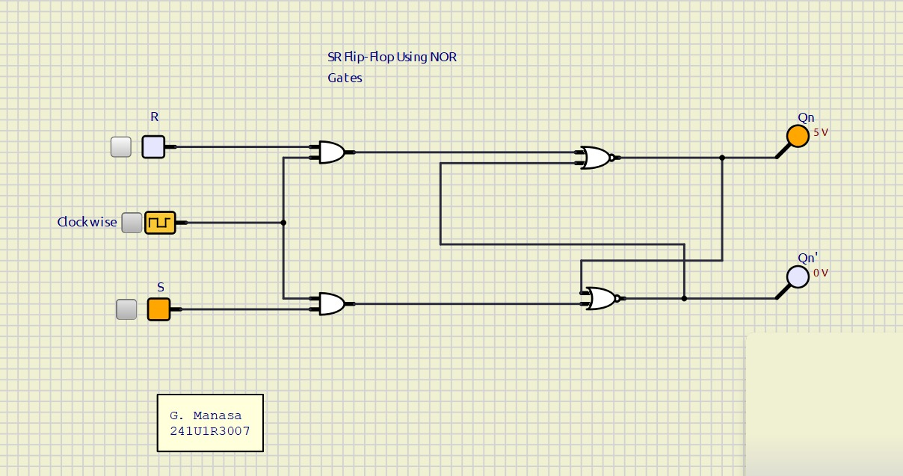
5.Result:
The SR flip-flop was designed, implemented, and tested using NAND and NOR gates. The simulation verified correct functionality and demonstrated how cross-coupled gates form a basic bistable storage element.
Simulation of JK Flip-Flop Using NAND and NOR Gates
1.Objectives
- To design and simulate a JK flip-flop using NAND and NOR gates in SimulIDE.
- To verify set, reset, hold, and toggle operations.
- To understand the truth table and working of JK flip-flops.
- To analyze how JK flip-flops eliminate the invalid state of SR flip-flops.
2.Software Required:
PC with SimulIDE software installed
3.Theory
The JK flip-flop is an improvement over the SR flip-flop. It removes the invalid state by allowing toggling when both inputs are active. It can be implemented using cross-coupled NAND or NOR gates with additional feedback paths.

1) JK Flip-Flop Operation:
- Inputs: J (Set), K (Reset), CLK (Clock)
- Outputs: Q (Normal), \bar{Q} (Complement)
- Operation:
  - J=0, K=0 → Hold (No change)
  - J=0, K=1 → Reset Q=0
  - J=1, K=0 → Set Q=1
  - J=1, K=1 → Toggle (Q switches state)
2) JK Flip-Flop Using NAND Gates:
- Implemented with 4 NAND gates and feedback connections.
- Edge-triggered version uses additional clock gating NAND gates.
3) JK Flip-Flop Using NOR Gates:
- Less common but possible by modifying SR NOR latch with feedback.
4.Procedure
A) JK Flip-Flop using NAND Gates:
- Place 4 NAND gates (plus 2 for clock if edge-triggered), 2 switches for J and K, 1 switch for CLK, 2 LEDs for Q and \bar{Q}.
- Cross-couple outputs and connect feedback paths.
- Apply clock pulses and various J, K inputs. Observe outputs.
B) JK Flip-Flop using NOR Gates:
- Place 4 NOR gates, J, K, CLK switches, LEDs for Q and \bar{Q}.
- Connect according to JK logic with feedback.
- Apply inputs and verify truth table.
5.Circuit Diagrams:
a. JK Flip-Flop Using NAND Gates

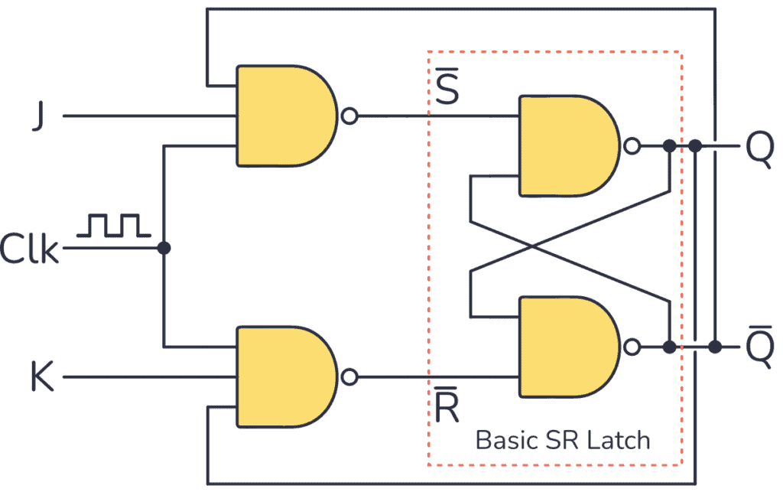
Truth Table
Clk | J | K | Q | Description
0 | X | X | Q | Clk in 0 no  change in Q
1 | 0 | 0 | Q | Memory  (no change)
1 | 1 | 0 | 1 | Set
1 | 0 | 1 | 0 | Reset
1 | 1 | 1 | Q̅ | Toggle
Simulation:
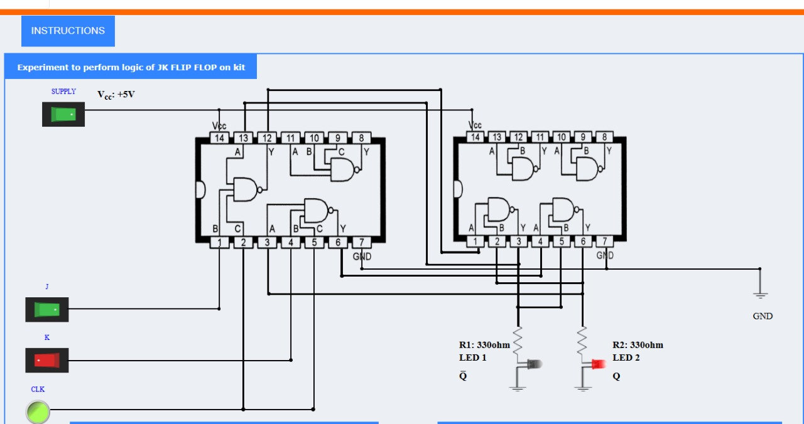
b.JK Flip-Flop Using NOR Gates

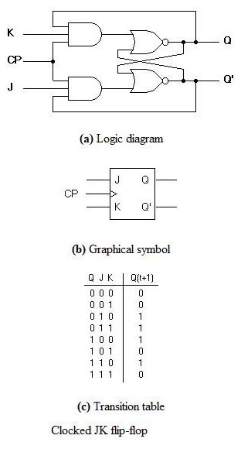
Simulation:
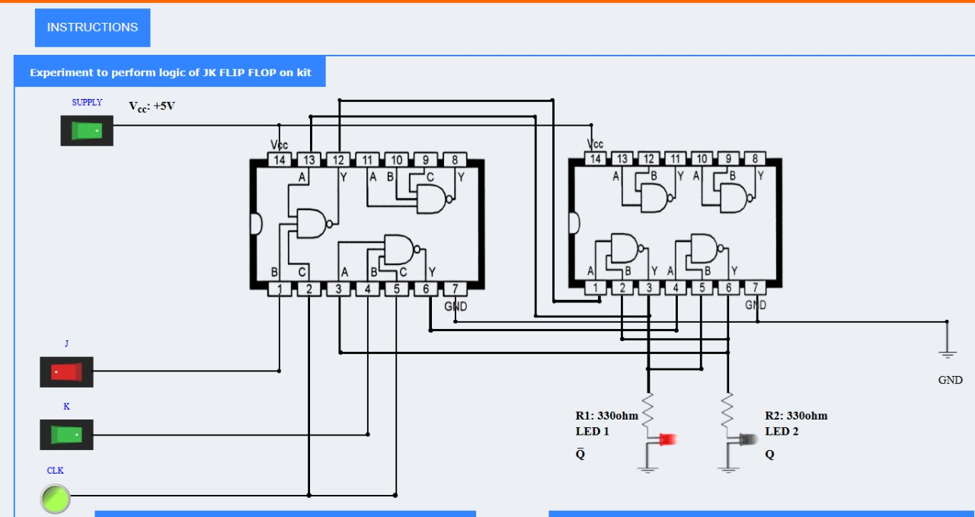
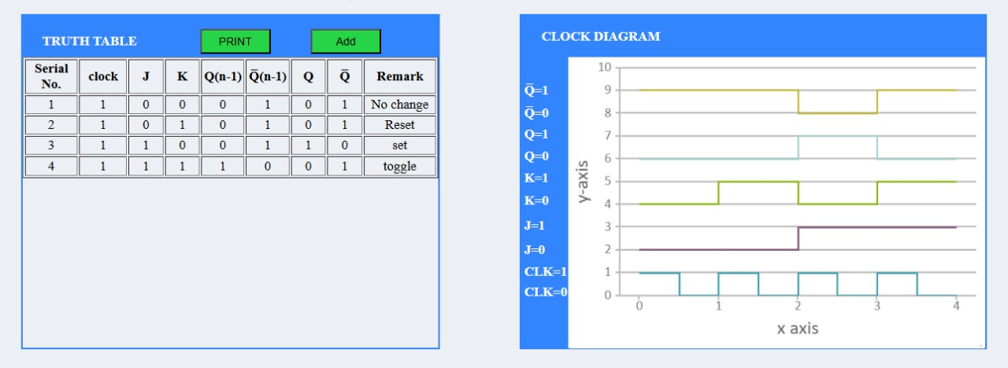
6.Result:
The JK flip-flop was designed and simulated using NAND and NOR gates in SimulIDE. The experiment verified set, reset, hold, and toggle operations, showing how the JK flip-flop improves upon the SR flip-flop

Simulation of D Flip-Flop Using NAND and NOR Gates
1.Objectives
- To design and simulate a D flip-flop using NAND and NOR gates in SimulIDE.
- To verify data storage and clocked operation of a D flip-flop.
- To understand the truth table and working of a D flip-flop.
2.Software Required:
PC with SimulIDE software installed
3.Theory
The D flip-flop (Data or Delay flip-flop) is derived from the SR flip-flop by eliminating the invalid state. It has a single input D and a clock input CLK.
1) D Flip-Flop Operation:
- Inputs: D (Data), CLK (Clock)
- Outputs: Q (Normal), \bar{Q} (Complement)
- Operation:
  - On the rising (or falling) edge of CLK, Q follows D.
  - When CLK is inactive, Q holds the previous state.
2) D Flip-Flop Using NAND Gates:
- Built from SR NAND latch with an inverter ensuring S=\bar{D} and R=D, controlled by CLK.
- Requires 4 NAND gates (plus 2 for clock control).
3) D Flip-Flop Using NOR Gates:
- Constructed similarly with an SR NOR latch and input gating.
4.Procedure
A) D Flip-Flop using NAND Gates:
- Place NAND gates, switch for D, switch for CLK, and LEDs for Q and \bar{Q}.
- Connect the circuit as per D flip-flop logic with clock gating.
- Apply various D values and clock pulses, observe Q output.
B) D Flip-Flop using NOR Gates:
- Place NOR gates for latch and input gating.
- Apply input values and clock signals to verify Q follows D on clock edge.
5.Circuit Diagrams:
a.D Flip Flop Using NAND Gates
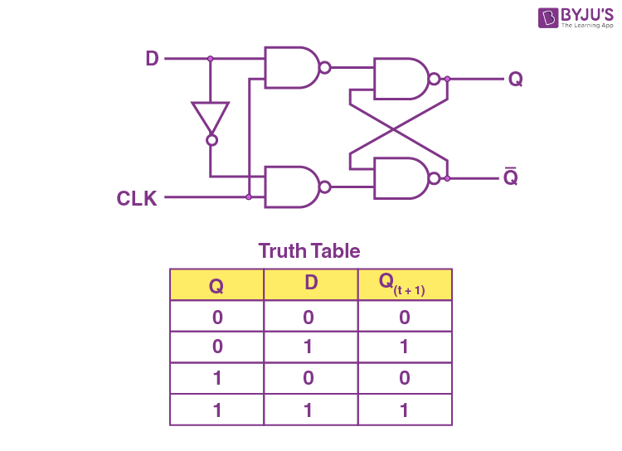
Simulation:

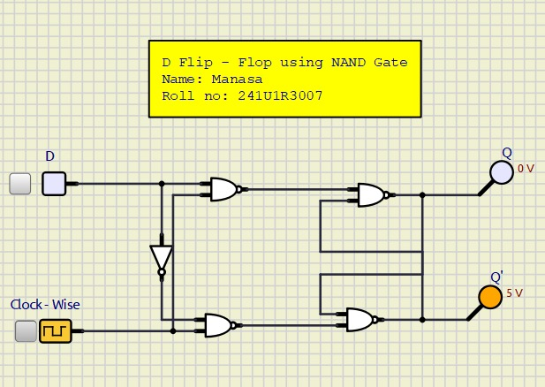
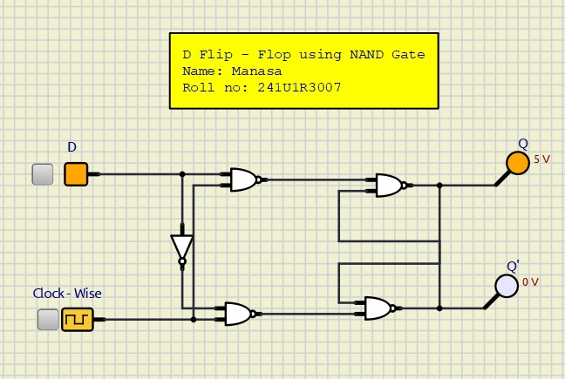
b.D Flip Flop Using NOR Gates
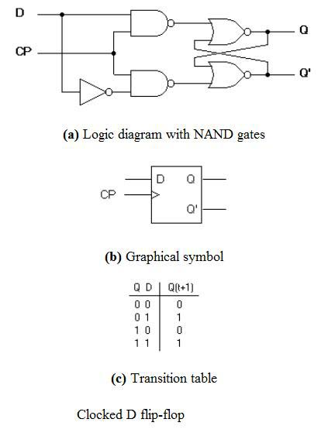
Simulation:
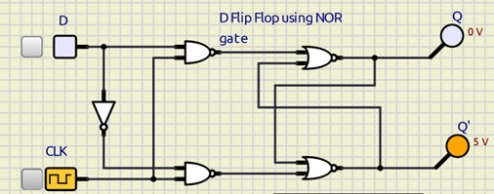

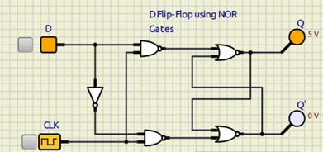

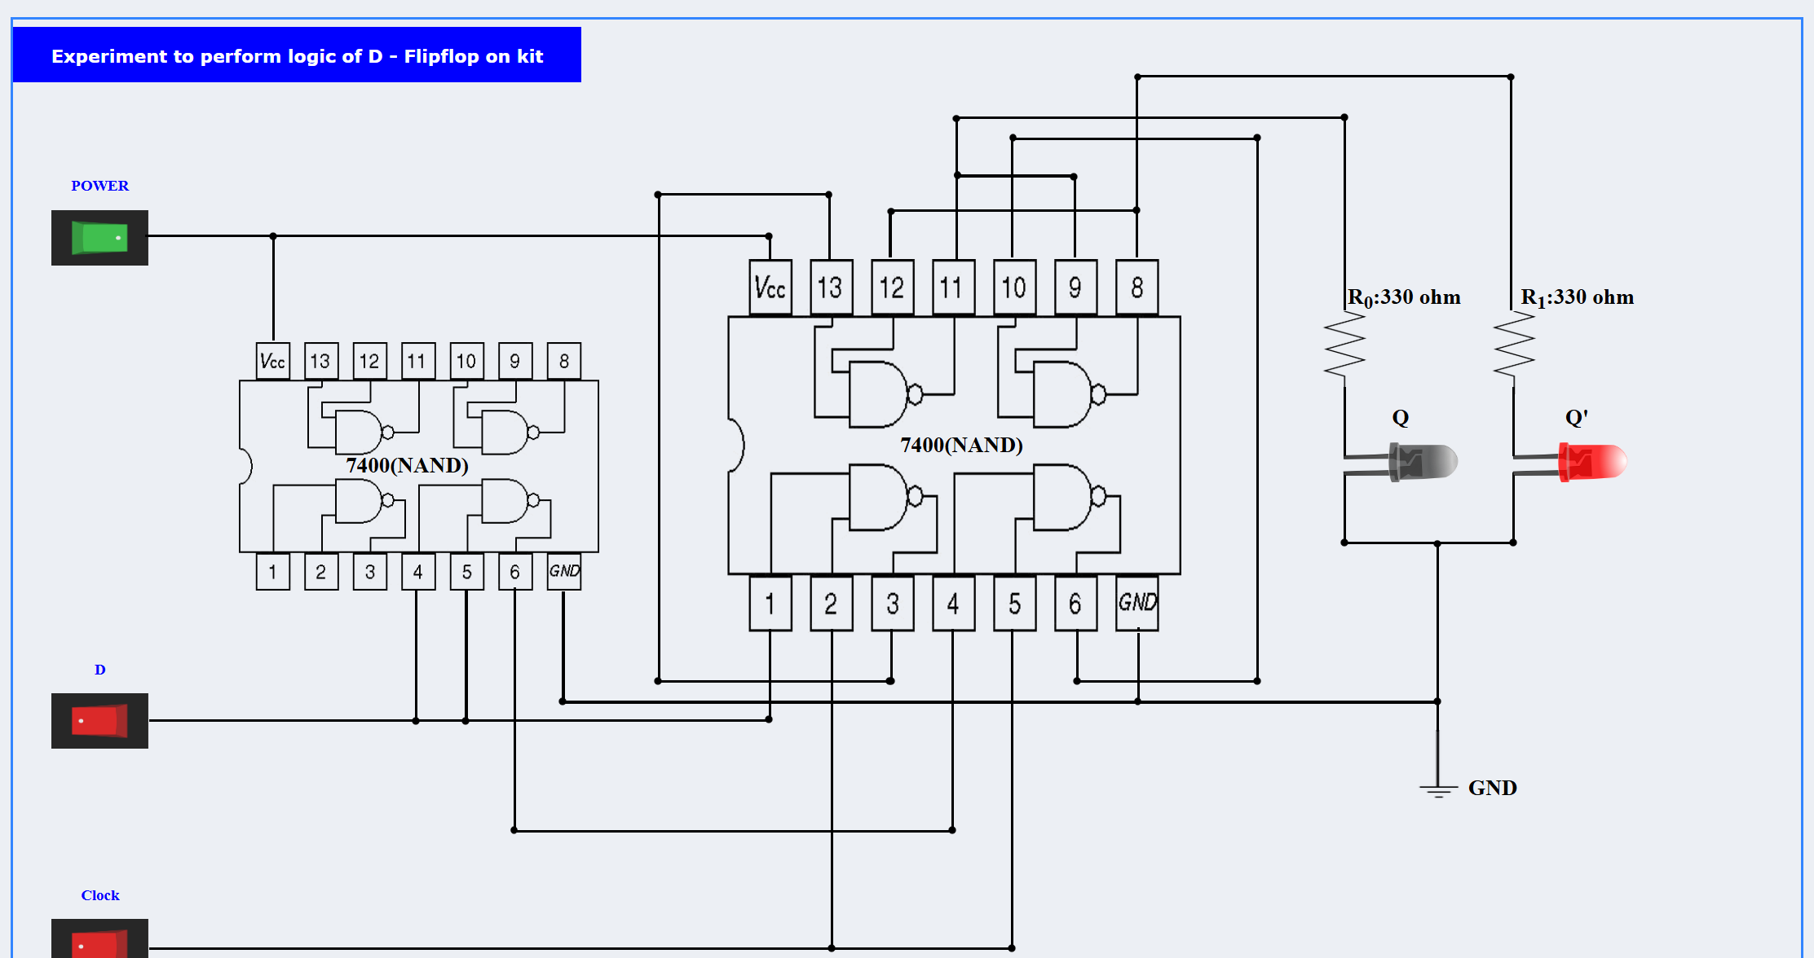

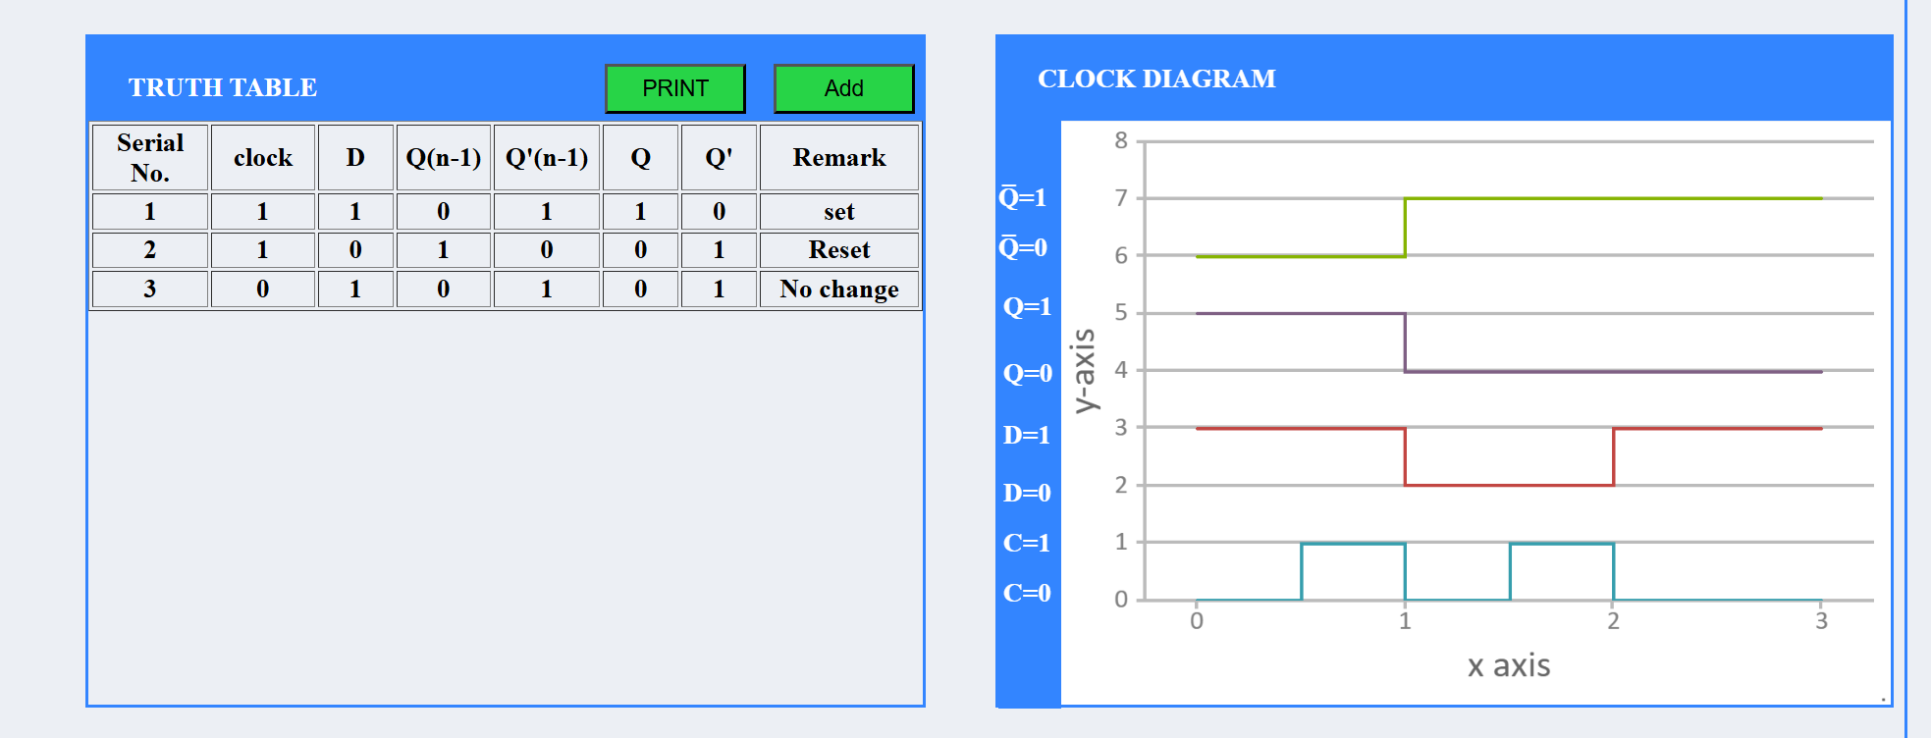

6.Result:
The D flip-flop was designed and simulated using NAND and NOR gates in SimulIDE. It successfully demonstrated data storage synchronized with clock pulses and eliminated the invalid state of SR flip-flops.
Simulation of T Flip-Flop Using NAND and NOR Gates

1.Objectives
- To design and simulate a T flip-flop using NAND and NOR gates in SimulIDE.
- To verify the toggle operation of a T flip-flop.
- To understand the truth table and applications of a T flip-flop.

2.Software Required:
PC with SimulIDE software installed

3.Theory
The T (Toggle) flip-flop is derived from the JK flip-flop by connecting J = K = T. It changes its output state (toggles) on every active clock edge when T=1, and holds its state when T=0.

1) T Flip-Flop Operation:
- Inputs: T (Toggle), CLK (Clock)
- Outputs: Q (Normal), \bar{Q} (Complement)
- Operation:
  - T = 0: Q remains unchanged (Hold)
  - T = 1: Q toggles on each clock edge (0→1 or 1→0)

2) T Flip-Flop Using NAND Gates:
- Implemented from a JK NAND flip-flop with J and K tied together.
- Requires 4 NAND gates for the basic JK latch and additional gates for clock control.

3) T Flip-Flop Using NOR Gates:
- Implemented similarly using a JK NOR latch with tied inputs.

4.Procedure

A) T Flip-Flop using NAND Gates:
- Place NAND gates, switch for T, switch for CLK, and LEDs for Q and \bar{Q}.
- Connect the circuit as per T flip-flop logic with toggle operation.
- Apply T=1 and clock pulses, observe toggling of Q

B) T Flip-Flop using NOR Gates:
- Place NOR gates for the latch and clock gating.
- Apply T=1, provide clock pulses, verify Q toggles each cycle.
5.Circuit Diagrams:
a. T Flip Flop Using NAND Gates
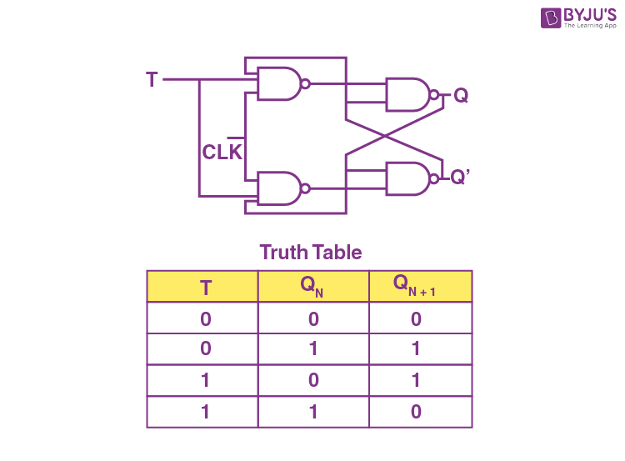

Simulation:
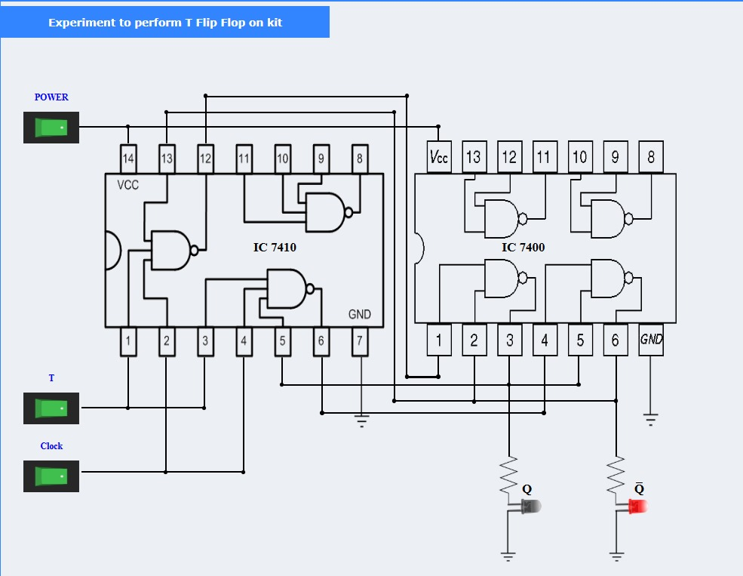
b.T Flip Flop Using NOR Gates
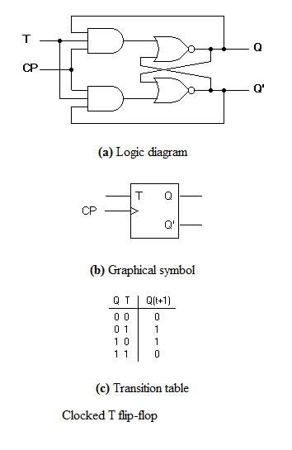
Simulation:
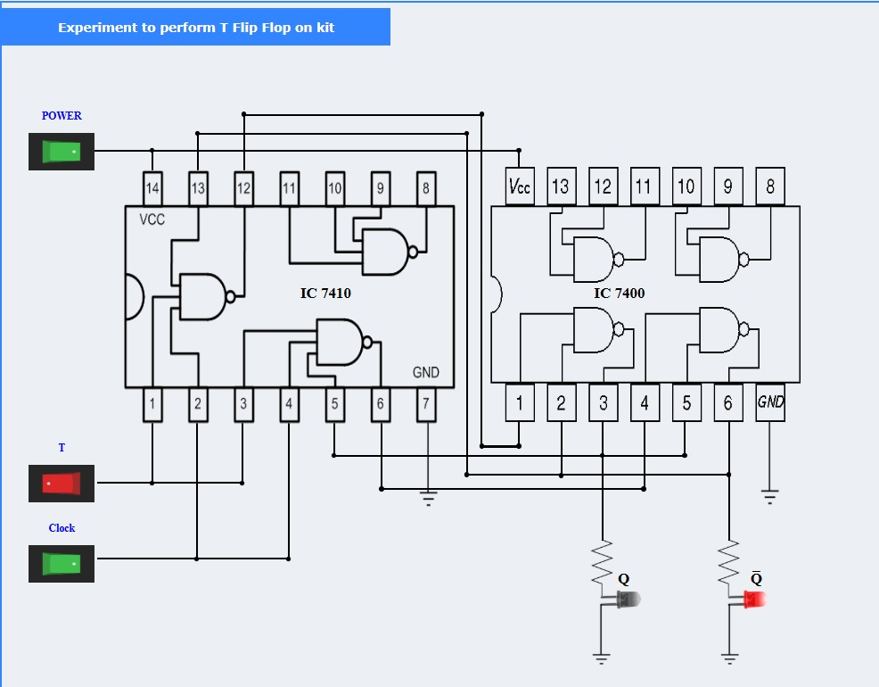

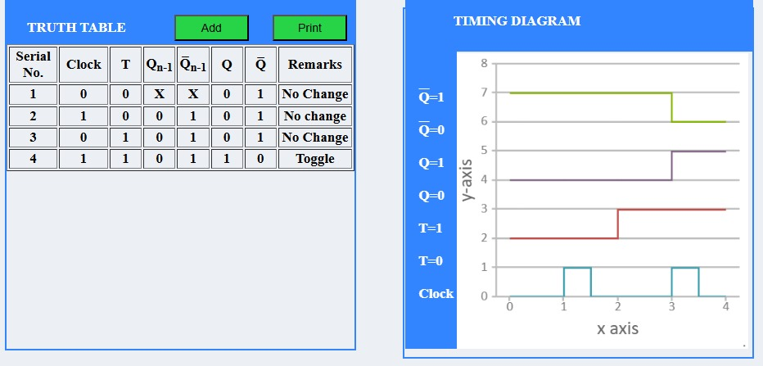
6.Result:
The T Flip-Flop was successfully implemented in SimulIDE using NAND and NOR gates. The output Q toggled on each active clock edge when T=1, confirming correct operation.

